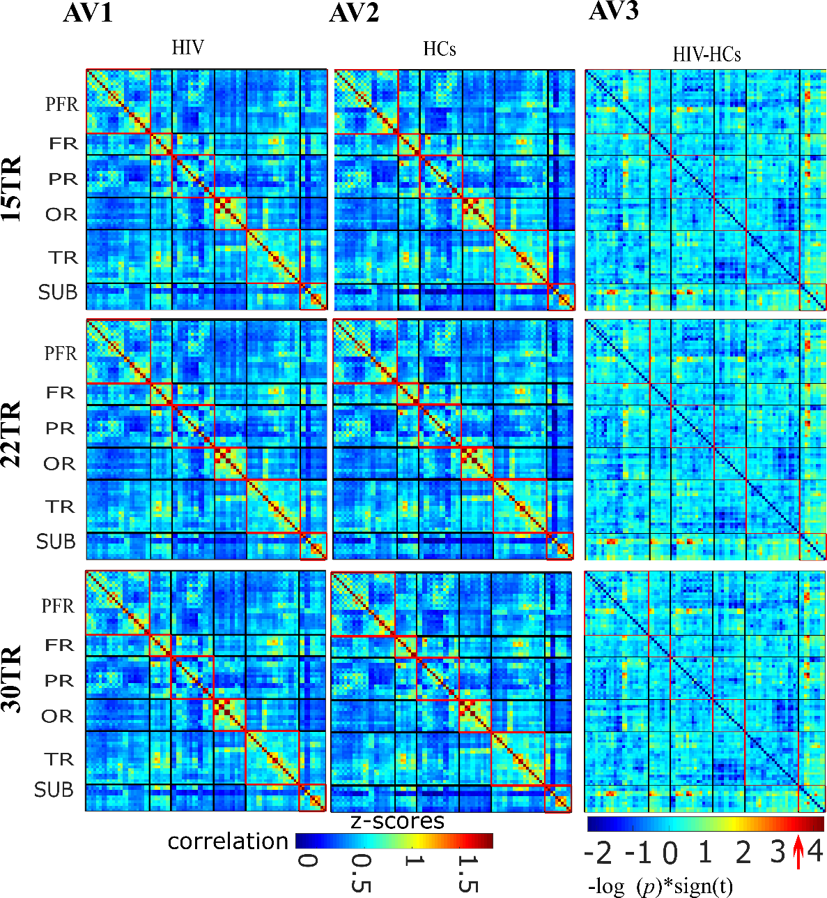
Supplementary Figure 1. The illustration of reproducibility of average dynamic RSFC maps at different window sizes (15TR, 22TTR, and 30TR). (AV1-AV2) Mean dynamic RSFC maps for healthy controls (column, AV1) and patients with HIV (column, AV2). Thick black lines partition the RSFC maps into six subcategories (i.e., prefrontal (PFR), other frontal (FR), parietal (PR), occipital (OR), temporal and subcortical regions. (AV3) The group difference (HIV–HCs) of dynamic RSFC (AV1-AV2). Values are plotted as−log10 (p-value) ×sign (t-statistic). Statistical significance was achieved at P<0.05.

